Technical Practice Section:

1. Add the hero and footer components into the app component page.

2. Retrieve a list of “inventory items” from the inventory service. Save it in the “items” variable in the app component.

3. Show how you would retrieve this data from an external endpoint.

4.Insert a counter component for each inventory item displaying the inventory name in the component.
5. Update the cart number by using an EventEmitter in the counter component. It should display the total of all counter component values.
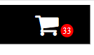

6. Finish the appStandardBackground directive to style the background of each counter component. It should have a color of “#D0D0D0” and rounded corners and add it to each counter.
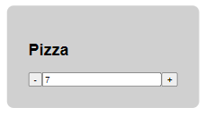

Final product should look similar to this:
